# What is a Method? – Explained with an Example

You have already used methods. A method is a particular grouping of statements that perform a function in a program, you write code to do something and reuse that code. An example might be finding a maximum;

**int** result;

**if** (num1 > num2)

result = num1;

**else**

result = num2;

If you define this function for finding a maximurm number between any two numbers in a method, you don’t have to repeatedly write the same code. You define it once and reuse it in other programs.

You have already used such methods. System.out.println, JOptionPane.showMessageDialogue, System.exit, Math.pow, Math.random. These methods are defined in the Java Library. Today we are going to create our own methods.

# Defining a Method

**modifier** returnValueType methodName(list of parameters){

//Method body;

}

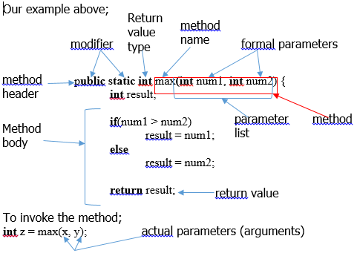

# Calling a Method

To use a method you need to ‘call’ or ‘invoke’ it. There are two ways, depending upon whether you need to return a value or not.

If you need to return a value the call to the method is usually treated as a value;

**int** larger = max(3, 4);

calls max and assigns the result of the method to larger

Another example; System.out.println(max(3,4));

If you do not need to return a value, the method returns **void.** For example**;**

System.out.println(“weleome”);

See TestVoidMethod.java

# **Time to Play, more notes tomorrow**

# Passing Parameters by Values example

(invoke with a parameter)

Increment.java and TestPassByValue.java

# Modularizing Code

(reduce redundant code)

GreatestCommonDivisorMethod.java

# Overloading Methods

(same idea, same solution, more or less or different parameters)

TestMethodOverloading.java

# The Scope of Variables

(local variable, local scope)

Error if you try this;

**for (int** I = 0; I < 10; i++) {

//do something

}

System.out.println(i);

i is not defined outside the for loop.

# The Math Class

Contains trigonomic methods, exponent methods, rounding methods, min and max, and abs methods (we didn’t need to create our method!), random and more.

Practice

1. Write an expression that returns a random integer between 24 and 45. Write an expression that returns a random integer between 0 and 999. Write an expression that returns a random integer between 2.2 and 22.2.
2. Write a method to convert between Celsius and Fahrenheit.
3. Write a method that print characters using the following header:

**public static void** printChars(**char** cr1, **char** chr, **int** numberPerLine)

1. Use the methods in RandomCharacter (given) to print 100 uppercase letters and then 100 single digits, and print 10 per line.